Mary Fielder (1949–2025)
Mary Fielder, known for her wonderful parties and her lifelong work with infectious disease researchers at the University of Washington, is now dancing with the angels.
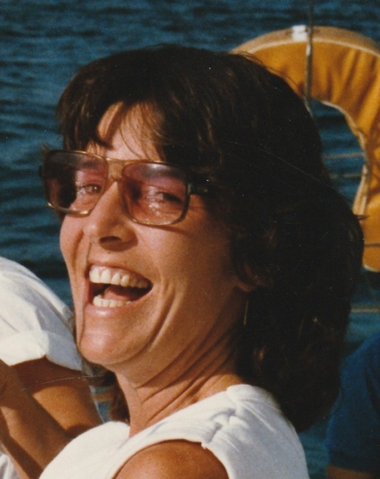
Mary died peacefully at home on Dec. 7 surrounded by friends and loved ones after being diagnosed with chronic obstructive pulmonary disease. She was 76. She went on hospice Nov. 3 and even from her hospice bed, Mary was inviting people over for Thanksgiving and delighting in the activity around her.
Mary selected a council of loved ones to help guide her passing. As part of this process, she asked that some of the ashes of her beloved boss, Dr. King Holmes, former chair of the UW Department of Global Health, be near her.
Mary worked with Dr. Holmes for more than 30 years and wielded considerable influence in her role as his executive assistant, gatekeeper, and student ambassador. Several graduate students from Peru who came to study under Dr. Holmes sent voice messages of love to “Mama Maria” in her final weeks.
“Mary taught me the meaning of unconditional care and compassion,” said Cecilia Zegarra. “I will carry her lessons and her love with me always.”
Mary’s duplex in Wallingford was a gathering place for Peruvian students, many of whom went on to become health leaders in their country.
In global health, students learn that it is often people like Mary who hold power and influence—not through titles but through their connections.
Mary was the ultimate networker and loved connecting people, including her future sister-in-law. In February 1996, Mary organized a group to meet mutual friends in Puerto Vallarta and go sailing. One of the people on the trip was Patsy Fielder, who was single at the time.
“On the airplane flying to Phoenix, she said to me, ‘By the way, you are going to meet my brother (Frosty) and fall in love and live happily ever after,’” Patsy said. “She changed my life.”
Mary was born Nov. 5, 1949, in Houston, Texas, to William and Beth Fielder. Her father, a World War II veteran, earned an engineering degree and moved the family to Scottsdale, Arizona. Her mother was part of WAVES (Women Accepted for Volunteer Emergency Service), a branch of the U.S. Naval Reserve. Mary’s nephew, Forrey Fielder, said his grandmother helped nurses care for soldiers with sexually transmitted diseases and mental illness.
The Fielders eventually moved to Washington state, and Mary graduated from Bellevue High School in 1969. Soon after high school, she began working at Harborview Medical Center. When the HIV/AIDS epidemic hit, Mary was part of the movement at UW that provided compassion and care to marginalized patients.
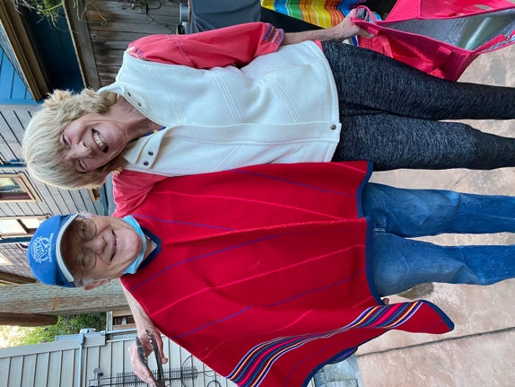
“People like King and Mary cut through prejudice, stigma, and fear, and met people where they were to give them dignity as human beings,” Forrey said.
Mary came of age in the 1970s, which deeply shaped her worldview. Her home once had a peace sign on the roof, and she proudly owned a button that read, “Hippest chick in Wallingford.”
She loved music and invited blues musicians to perform in her backyard. She always had a dog by her side. Her dog, Mojo, has since been rehomed with a wonderful neighbor and colleague in global health.
King Holmes and Mary Fielder (Cinco de Mayo.)

Mary’s home away from home was the Santa Maria Hotel in Melaque, Mexico—a place she returned to for 25 years, from 1997 to 2022.
Her close friend Paul “Paablo” Carlson of Seattle met her there in 2000. He described the hotel as a mix of winter camp, a college dorm reunion, and family, filled with potlucks, music, and plenty of shenanigans. Mary started the Arts and Science Fair, where people created playful projects—such as a choir made of beer cans or experiments exploring what happens when soda meets chemicals.
“Mary was a major part of it,” he said of her impact on the community. “She was organizing people and micromanaging like a producer.”
Mary’s friend Kimberly Clark Sharp, who met her at Harborview in the mid-1970s, said Mary had the deepest impact of any friend.
“Mary had a lot of love for all good people,” she said. “She elevated countless people in their careers and social situations. If you’ve ever seen Auntie Mame, you’ve met Mary Fielder.”
Kimberly, a social worker specializing in death and dying, was by Mary’s side in her final days. She said Mary would squeeze her hand as she spoke and talked about how to communicate from the other side.
Kimberly described a vision she shared with Mary: a wide path lit on each side, leading to a cement pad strung with party lights.
“That was her reception hall,” she said. “She was going home.”

